The Trial of Cardigan Jones
By: Tim Egan
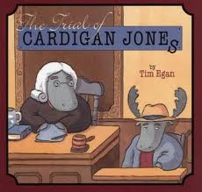
Vocabulary Words
- trial - a meeting in court to decide if someone has broken the law
- jury - the group of people who make the decision in a trial
- convinced - made some one believe or agree to something
- guilty - having done something wrong
- pointed - use a finger to show where something was
- murmur - the sound of people speaking very softly
- honest - truthful
- stand - the place where a witness in a trial sits while being questioned

Summary: Cardigan Jones, clumsy new moose in town, finds himself in the middle of the case of a missing apple pie. As he moves past many misconceptions, all is resolved in court.
Spelling Words
1. spoke
2. mile
3.save
4. excuse
5. cone
6. invite
7. cube
8. price
9. erase
10. ripe
11. broke
12. flame
13.life
14. rule
15. these
16. those
17. surprise
18. decide
19. trial
20. convince

Learning Links:
http://www.spellingcity.com/MsShipton/

Genre
Fantasy

Target Skill
Conclusions

Target Strategy
Infer/Predict

Vocabulary Strategy
Compound Words

Fluency
Phrasing

Phonics
Long vowels a e i o u
(VCe pattern)

Essential Question:
Why are courts an important part of our government?

