Roberto Clemente: Pride of the Pittsburgh Pirates
By: Jonah Winter
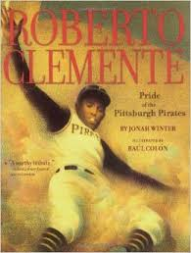
Summary: Cardigan Jones, clumsy new moose in town, finds himself in the middle of the case of a missing apple pie. As he moves past many misconceptions, all is resolved in court.
Vocabulary Words
- stands: seats at a stadium or ballpark
- fans: great admirers
- score: to make a point in a game
- league: group of teams that compete against one another
- slammed: hit with sudden force
- polish: to make shine; to make something better
- style: a way of doing something
- pronounced: said clearly and correctly
Spelling Words
1. slight
2. mild
3. sight
4. pie
5. mind
6. tie
7. pilot
8. might
9. lie
10. tight
11. blind
12. flight
13.die
14. midnight
15. find
16. night
17. silent
18. frightening
19.kind
20. light

Learning Links:
http://www.spellingcity.com/MsShipton/

Genre
Biography

Target Skill
Cause and Effect

Target Strategy
Visualize

Vocabulary Strategy
Prefix mis

Fluency
Intonation

Phonics
Long i spelled i, ie, igh

Essential Question:
What are the traits of a hero?

