Destiny’s Gift
By: Natasha Anastasia Tarpley
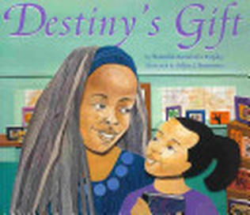
Summary: Destiny loves words and her favorite place in the world is Mrs. Wade's bookstore. On Saturdays, Destiny helps Mrs. Wade at the store and at the end of the day they relax together, drinking tea and reading. One Saturday, Mrs. Wade does not seem her usual self and Destiny learns that the bookshop is about to close. Destiny is determined not to let this happen. As she rallies the community to help keep the store open, she also creates an imaginative journal for Mrs. Wade that captures the warmth and special magic of the store forever.
Vocabulary Words
1. block: the section of the street between two other streets
2. spreading: stretching something out
3. raise: to collect
4. figure: to work out by thinking
5. contacted: got in touch with someone
6. customers: people who buy something at a store
7. afford: to be able to pay
8. earn: to get something by working

Spelling Words
1. lay
2. real
3.trail
4. sweet
5. today
6. dream
7. seem
8.tea
9. treat
10. afraid
11. leave
12. bait
13.screen
14.speed
15.paint
16. please
17. yesterday
18. explain
19. raise
20. earn

Learning Links:
http://www.spellingcity.com/MsShipton/

Genre
Realistic fiction

Target Skill
Understanding characters

Target Strategy
Analyze/evaluate

Vocabulary Strategy
Antonyms

Fluency
Reading rate

Phonics
Common vowel pairs
ai, ay, ee, ea

Essential Question:
Why is volunteering good for a community and its people?

